Solve the SQL fundamentals Query:

1. Display the name of movies, movie type is starts with Drama.

ANS: select moviename from movie where Movietype like "Drama%";

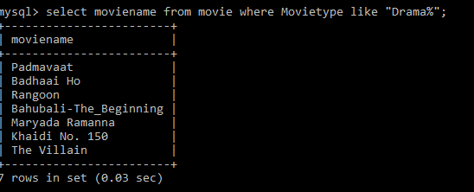

1. Display the movies acted by actor Ayushmann.

Ans: select Moviename from movie where Heroname like "Ayushmann";

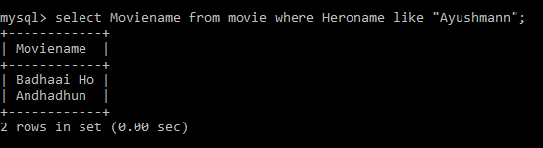

1. Display the count of movies, having length above 18.

Ans:select count(Moviename) from movie where Length>18;

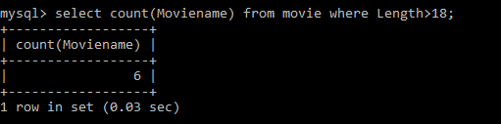

1. Display the movie having minimum length.

Ans: select Moviename from movie where Length=(select min(Length) from movie);

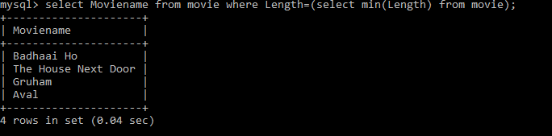

1. Display all the details of movie, the language that first name starts with ‘T’

Ans: select \*from movie where Language like 'T%';

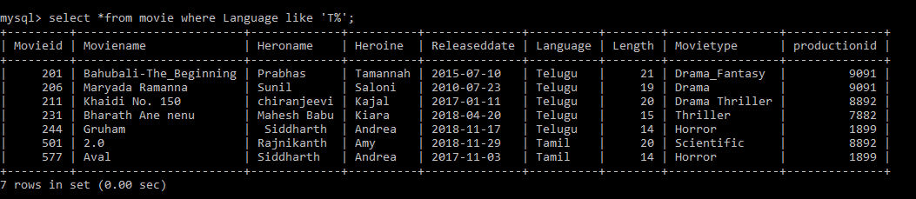

1. Display the movie name, hero name, heroine name whose having maximum length.

Ans:select Moviename,Heroname,Heroine from movie where Length=(select max(Length)from movie);

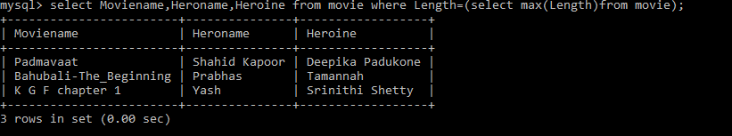

7.Display the movie name, hero name, heroine name the movie released after 15 march 2018.

Ans:select Moviename,Heroname,Heroine from movie where Releaseddate>'2018-03-15';

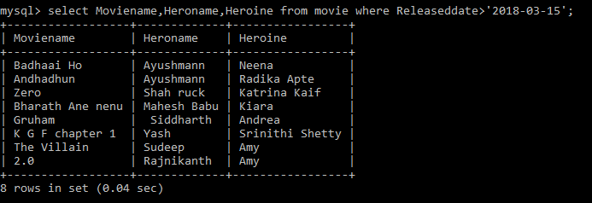

8.Display the count of thriller movies.

Ans:select count(Moviename) from movie where movietype like '%Thriller';

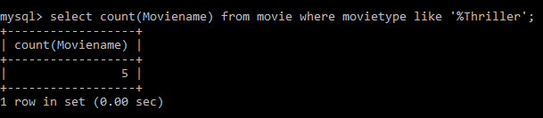

9Display the count of movies whose released before 15 march 2018.

Ans: select count(Moviename) from movie where Releaseddate<'2018-03-15';

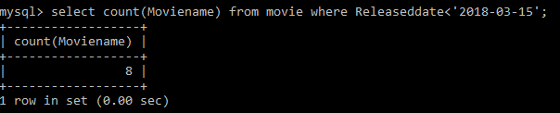

1. Display the release date of the movie name ‘Zero’.

Ans:select Releaseddate from movie where Moviename='Zero';

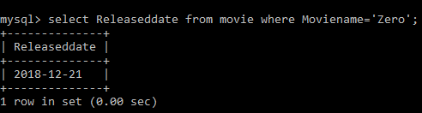

11.Display the actor name that acted with ‘Amy’.

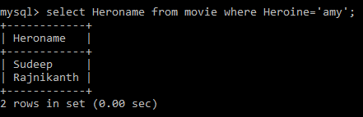

12.Display the Count of maximum movies released in a month of October.

select Hero name from movie where Heroine='amy';

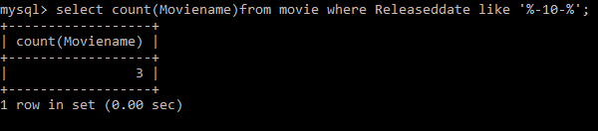

13.Display the movie names whose production id for different languages.

Ans: select moviename,Productionid from movie ;

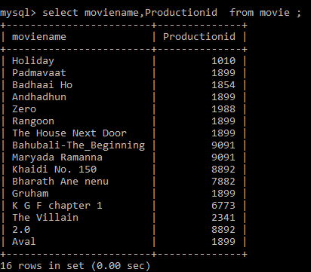

Solve Advanced Query by using the Two Tables:

1.

Write the query to display productionid, production name with total number movies produced by each.

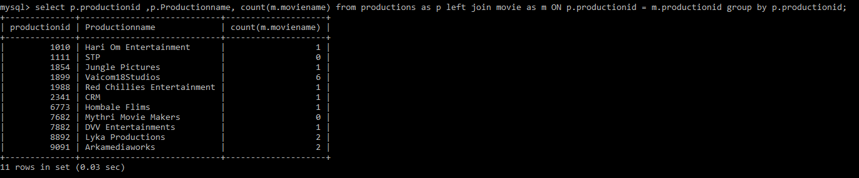

2.

Write the query to display production name, owner name have produced more than 2 movies.

SELECT productions.productionname,productions.ownername,COUNT(\*)

FROM productions

INNER JOIN movie ON movie.productionid = productions.productionid

group by productionname

HAVING COUNT(\*)>2;

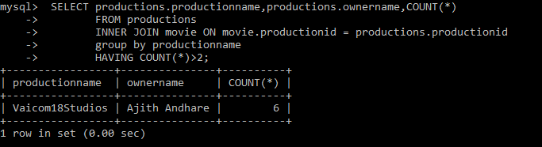

3.

Write the query to display production name, owner name have produced maximum movies

SELECT productions.productionname,productions.ownername

FROM productions

INNER JOIN movie ON movie.productionid = productions.productionid

group by productionname

ORDER BY COUNT(\*) DESC

LIMIT 1;

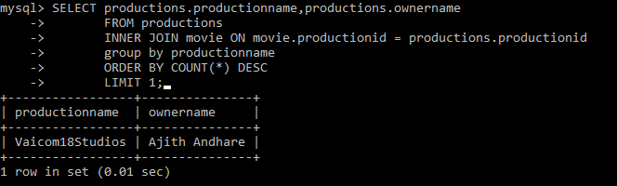

4.

Write the query to display the moviename, heroname and productionname acted in the producer name= ’Subaskaran’.

SELECT movie.moviename,movie.HeroName,productions.productionname

FROM productions

INNER JOIN movie ON movie.productionid = productions.productionid

WHERE ownername='Subaskaran';

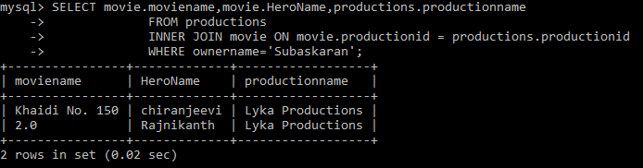

5.

Write the query to display the moviename, heroname whose productionid ends with 82.

SELECT movie.moviename,movie.HeroName FROM productions

INNER JOIN movie ON movie.productionid = productions.productionid

WHERE

movie.productionid LIKE '%82';

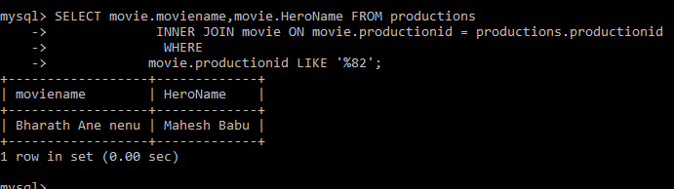

6.

Write the query to display the productionname, ownername who has not produced the movie.

SELECT productions.productionname,productions.ownername FROM productions

LEFT JOIN movie ON movie.productionid = productions.productionid

WHERE moviename IS NULL;

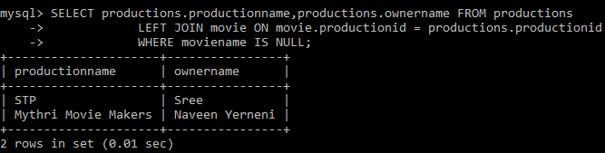

7.

Write the query to display the productionname, ownername who has not produced the ‘hindi’ movie.

select p.Productionname,p.Ownername from productions p left join movie m on m.Productionid=p.productionid and m.language="Hindi" where

m.Language is null;

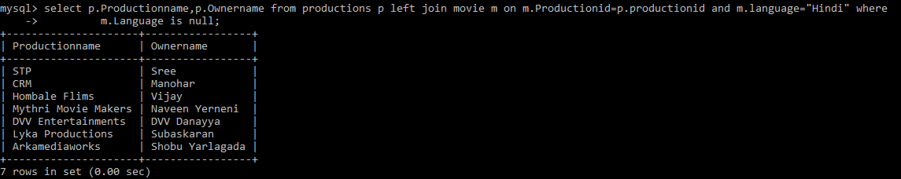

8.

Write the query name to display the heroinename who acted in the different productions but not in same production id.

9.

Write the query to display the heroname who acted in maximum languages.

Ans: select distinct Heroname ,Language , count(Heroname) as result from movie group by(Language) order by (result) desc limit 1;

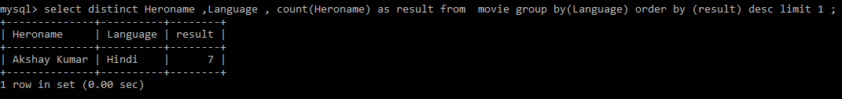

10.

Write the query to display the production name, owner name who has produced movie for more languages.

Ans:

select Distinct p.Productionname,p.Ownername ,count(p.Productionname) as counter from movie as m right join productions as p ON m.productionid =p.productionid group by(m.language) order by(counter) desc limit 1;



11.

Write the query to display the productionname, producername who has not produced any movie.

Ans: select p.Ownername ,p.Productionname from movie as m right join productions as p ON m.productionid =p.productionid where m.moviename is null ;

